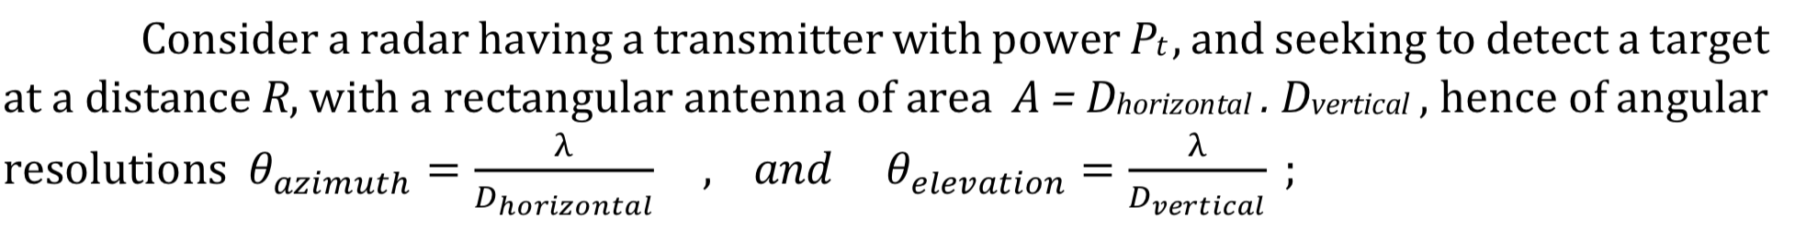

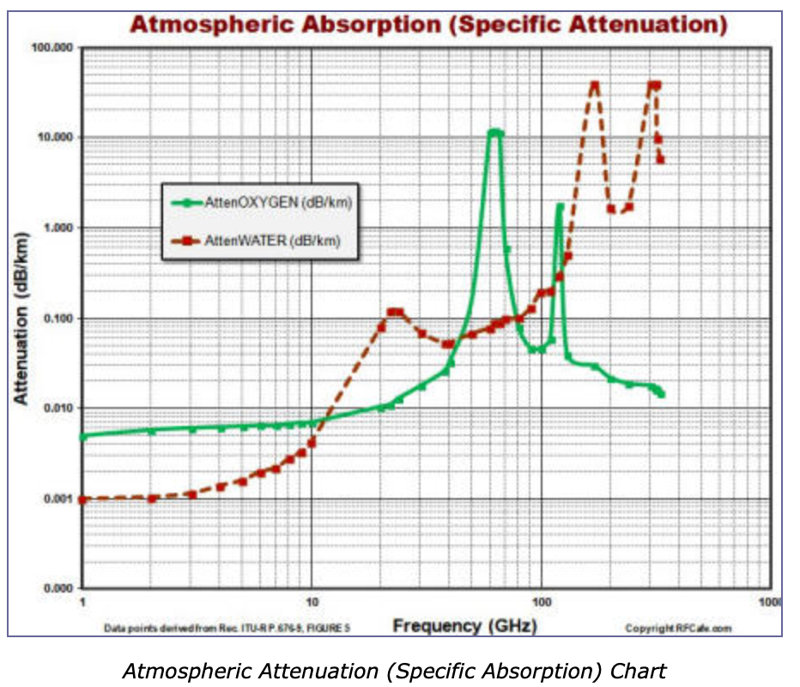

**Converting dBW(watt) to dBm(milliwatt) and Vice Versa**

**dBm = dBW + 30** or **dBW = dBm - 30**

**Converting Radar Power in Watts to Decibels**

**dBW = 10 x log10(PowerWatts)**  
PowerWatts: Transmitter power output in watts.

|  |
| --- |
| **EXAMPLE:**What is the dBW of a 1 megawatt radar?  **10 x log10(1,000,000) = 60 dB** |

**Converting Radar Power in Decibels to Watts**

**PowerWatts = 10(Decibels/10)**

PowerWatts: Transmitter power output in watts.  
Decibels: Transmitter power output in decibels.

|  |
| --- |
| **EXAMPLE:**What is the power in watts of a 100 dBw radar?  **10(100/10) = 10,000,000,000 watts.** |

**Converting Radar Cross Section in Square Meters to Decibels**

**dBsm = 10 x log10(RCS/1m2)**

dBsm: Radar Cross Section of target in decibels.  
RCS: Radar Cross Section of target in square meters.

|  |
| --- |
| **EXAMPLE:**What is the dBsm of a stealth fighter with a RCS of 0.01 m2?  **10 x log10(0.01/1m2) = -20 dBsm** |

**Converting Radar Cross Section in Decibels to Square Meters**

**RCS = 10(Decibels/10)**

RCS: Radar Cross Section of target in square meters.  
Decibels: Radar Cross Section of target in decibels.

|  |
| --- |
| **EXAMPLE:**What is the RCS in square meters of an aircraft with a RCS of 5 dB?  **10(5/10) = 3.16 m2** |

**Converting Antenna Gain into Decibels Relative to Isotropic (dBi)**

**dBi = 10 x log10(Gain/1)**